# CS 255 System Design Document

## UML Diagrams

### UML Use Case Diagram

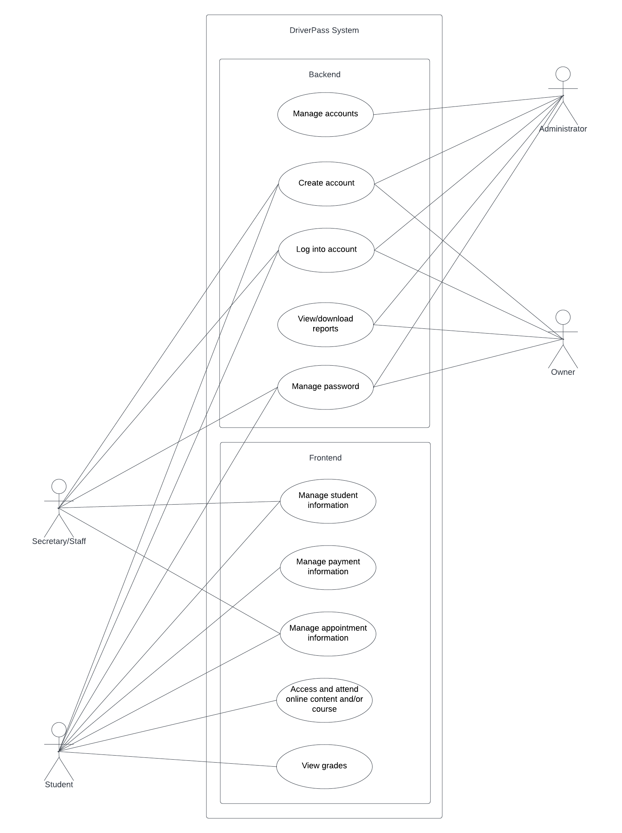

### UML Activity Diagrams

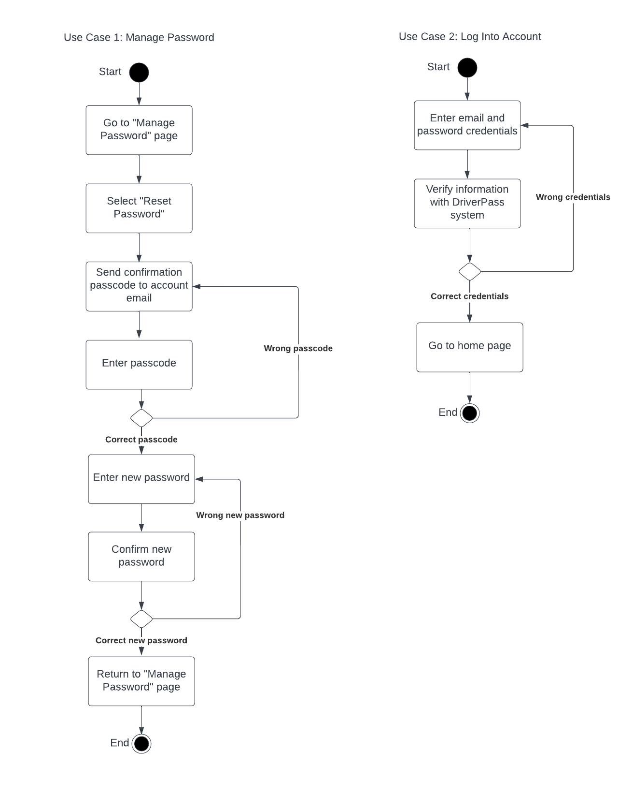

### UML Sequence Diagram

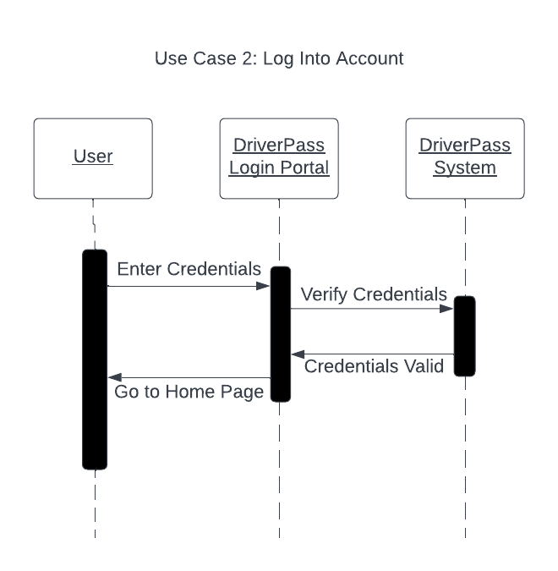

### UML Class Diagram

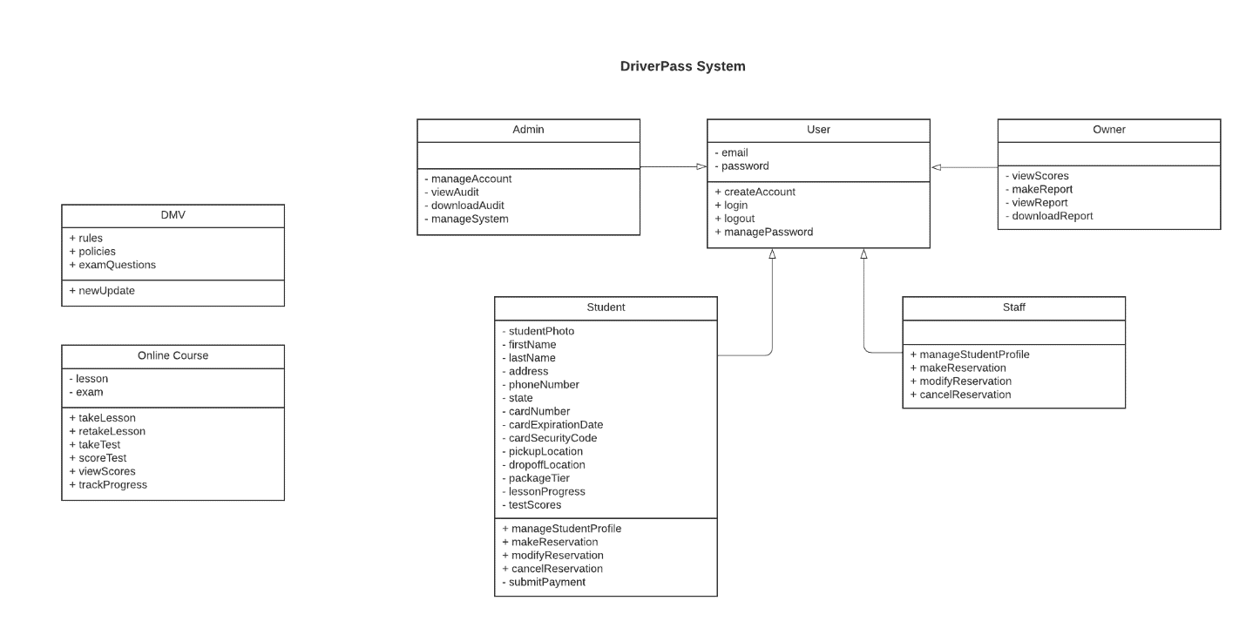

## Technical Requirements

* The user must have a stable internet connection.
* The user must have access to a recent model computer, cell phone, or tablet device that supports either Microsoft Windows, Mac, iOS, or Android.
  + This device must be updated to the latest version of the operating platform.
* The user must have a working email address.
* The user must have a working phone number.
* The user must have a valid address for pickup if they opted for in-person lessons.
* The user must have their drivers license information on hand when first registering for a DriverPass account.